Visualizing the Global Air Transportation

Network: Unlocking Insights with Tableau
PROJECT: 3
PROJECT NAME: UNLOCKING INSIGHTS INTO
GLOBAL AIR TRANSPORTATION NETWORK WITH
TABLEAU
S.YOGESWARI
J.NAGAARJUN
V.RAJESH KANNA
S.VIGNESH KUMAR.

Introduction

Welcometo the presentation on Visualizing the Global Air Transportation Network: Unlocking Insights with Tableau. Thispresentation willexplore how Tableau can be used to analyzeand visualizedata related to the global air transportation network.We willdiscusstheimportanceof understanding thisnetwork and how Tableau can help in gaining valuable insights.

The air transportation network is a complex system connecting airports worldwide. It plays a crucial role in global connectivity and economic development. By analyzing data related to routes, passenger traffic, and airline operations, we can gain a deeper understanding of this network's dynamics and identify patterns and trends.


Analyzing air transportation data poses several challenges. The vast volume of data, including flight schedules, passenger information, and airline performance, requires powerful tools.Additionally, the complexity of the network and the need for real-time analysis demand advanced visualization techniques to unlock valuable insights.

Introduction to Tableau

Tableauis aleading data visualizationand businessintelligencetool.It providesa user-friendlyinterfaceand powerful capabilities for exploring and presenting data. With Tableau, analysts can create interactivevisualizations,dashboards,and reportsthat enabledeep analysisand effective communication of insights.
Benefits of Tableau for Air Transportation Analysis

Tableau offersseveralbenefitsfor analyzing air transportation data. It enablesinteractiveexploration of complex datasets, allowing users to drill down into specific areas of interest. Its real-time capabilitiesfacilitatemonitoring offlight operationsand performance.Moreover, Tableau's visual storytelling features enhance communication and help stakeholdersunderstand the insights derived from the data.
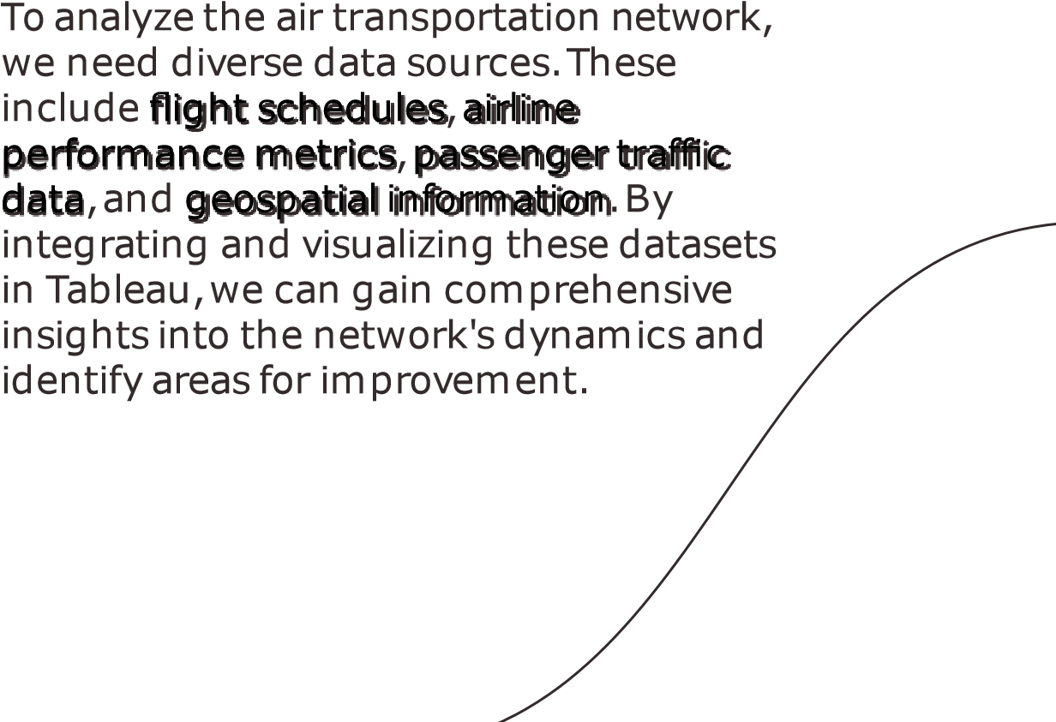
Data Sources for Air Transportation Analysis


Visualizing Airline Routes

Visualizing airlineroutesisakeyaspect of understanding theairtransportation network.Tableau allowsusto create dynamic routemapsthat displaythe connectionsbetween airportsand highlight themost frequentlytraveled routes.These visualizationshelp identify majorhubs,populardestinations,and potentialareasforroute optimization.

Analyzing Passenger Traffic

Analyzing passengertraffic patternsis crucialforoptimizing airlineoperations. Tableau enablesusto createinteractive dashboardsthat provide insightsinto passengervolumes,busiestairports,and populartravelroutes.Byanalyzing this data,airlinescan make informed decisions regarding fleet allocation,scheduling,and capacityplanning.

Monitoring Airline Performance
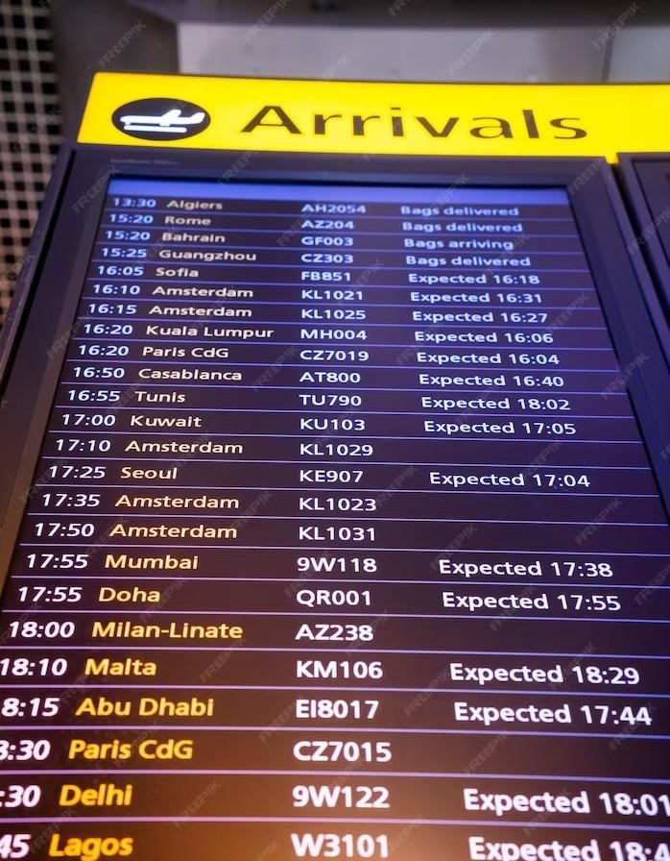
Monitoring airlineperformancemetricsis essential for ensuring operational efficiencyand customersatisfaction. Tableau allows us to create real-time performancedashboardsthat trackkey indicatorslike on-time performance,flight delays,and customerfeedback.By visualizing this data, stakeholders can identifyareasthat requireimprovement and take proactivemeasures.



Identifying Network Bottlenecks
I
d
e
n
t
i
f
y
i
n
g
n
e
t
w
o
r
k
b
o
t
t
l
e
n
e
c
k
s
a
n
d
congestion
points
is
crucial
for
optimizing
the
air
transportation
system.
With
T
a
b
le
a
u
,
w
e
c
a
n
a
n
a
l
y
z
e
d
a
t
a
o
n
fl
i
g
h
t
d
e
l
a
y
s
,
c
a
n
c
e
ll
a
t
i
o
n
s
,
a
n
d
a
i
r
t
r
af
fi
c
congestion
to identify
problem
areas.
By
visualizing
these
insights,
stakeholders
can
w
o
r
k
t
o
w
a
r
d
s
i
m
p
r
o
v
i
n
g
e
f
fi
c
i
e
n
c
y
,
r
e
d
uc
i
n
g
d
e
l
a
y
s
,
a
n
d
e
nh
a
n
c
i
n
g
o
v
e
r
a
l
l
n
e
t
w
o
r
k
p
e
r
f
o
r
m
a
n
c
e
.

Predictive Analytics for Air Transportation

Tableau's predictive analytics capabilities can be leveraged toforecast futuretrends in airtransportation.Byanalyzing historicaldataon passengerdemand, routeperformance,and economic indicators,we can make informed predictionsabout future airtravelpatterns. Theseinsightscan assistin strategic decision-making,resourceallocation,and capacityplanning.

Data Visualization Best Practices
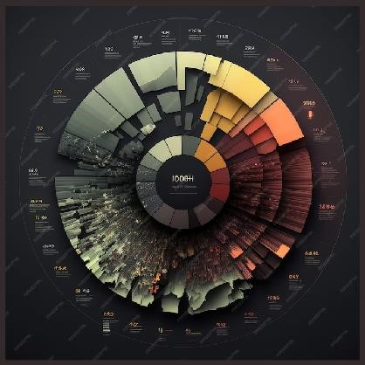
Effective data visualization is essential for conveying insights accurately. Tableau providesseveralbest practicesforcreating impactfulvisualizations,such aschoosing appropriatecharttypes,using color effectively,and providing clearlabels.By following theseguidelines,we can ensure that ourvisualizationsare intuitive, informative,and visuallyappealing.

Inthis casestudy,we will explorehow Tableauwasused to optimize airlineroutes based on passenger demand and profitability.By analyzinghistoricaldata and visualizing keymetrics, we were able to identify underperforming routes, discover new market opportunities, and propose route adjustments thatresulted in increased revenueand customer satisfaction.

Case Study: Improving Airport Efficiency

In thiscase study,we willdemonstrate how Tableau helped improveairport efficiencybyanalyzing passengerflow, securitywait times,and baggagehandling processes. By visualizing bottlenecks and identifying areasforimprovement,we were able to streamlineoperations,reduce wait times,and enhancethe overall passengerexperience.

Conclusion

Tableau offers powerful capabilities for analyzing and visualizing data related to the global air transportation network.By leveraging Tableau's interactive features,realtime capabilities, and predictive analytics, stakeholders can unlock valuable insights to optimize operations, improve customer experience,and make data-driven decisions. Visualizing the air transportation network with Tableau opens up a world of possibilities for understanding and enhancing this vital global system.
Thanks!

